Union of Loci

Definition
# Source: AI Source: Provided by: [Data Path: Persons Table -> ID Column: 1, Name_En Column: Motasem Essam] -> From: [ChatGPT] on [7/25/2026]
Union of Loci is the set of all points that belong to at least one of two or more loci.
If $L_{1}$and $L_{2}$are two loci, their union is written as:
$$\boxed{L_{1}∪L_{2}}$$
A point $P$belongs to the union when:
$$\boxed{P∈L_{1}∪L_{2} ⟺ P∈L_{1}\text{ or }P∈L_{2}}$$
The word “or” is important: the point may belong to the first locus, the second locus, or both.

Simple Definition
# Source: AI Source: Provided by: [Data Path: Persons Table -> ID Column: 1, Name_En Column: Motasem Essam] -> From: [ChatGPT] on [7/25/2026]
The union of loci is the collection of all points satisfying at least one of the given locus conditions.
For example, if:
- $L_{1}$is a circle centered at $A$
- $L_{2}$is a circle centered at $B$
then:
$$\boxed{L_{1}∪L_{2}}$$
contains every point on either circle.

Fundamental Concept
# Source: AI Source: Provided by: [Data Path: Persons Table -> ID Column: 1, Name_En Column: Motasem Essam] -> From: [ChatGPT] on [7/25/2026]
Suppose a geometric problem gives two conditions:
$$C_{1}$$
or
$$C_{2}.$$
Convert each condition into a locus:
$$C_{1}→L_{1} \\ C_{2}→L_{2}$$
Then the complete solution is:
$$\boxed{L_{1}∪L_{2}}$$
The process is:
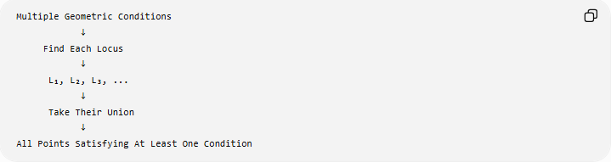
Multiple Geometric Conditions
↓
Find Each Locus
↓
L₁, L₂, L₃, ...
↓
Take Their Union
↓
All Points Satisfying At Least One Condition

Main Types of Union of Loci
# Source: AI Source: Provided by: [Data Path: Persons Table -> ID Column: 1, Name_En Column: Motasem Essam] -> From: [ChatGPT] on [7/25/2026]
A practical classification is:
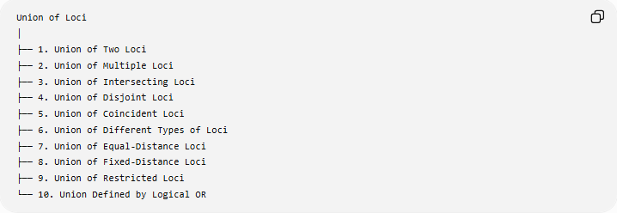
Union of Loci
│
├── 1. Union of Two Loci
├── 2. Union of Multiple Loci
├── 3. Union of Intersecting Loci
├── 4. Union of Disjoint Loci
├── 5. Union of Coincident Loci
├── 6. Union of Different Types of Loci
├── 7. Union of Equal-Distance Loci
├── 8. Union of Fixed-Distance Loci
├── 9. Union of Restricted Loci
└── 10. Union Defined by Logical OR
These are descriptive/practical categories, rather than universally standardized formal types.

1. Union of Two Loci
# Source: AI Source: Provided by: [Data Path: Persons Table -> ID Column: 1, Name_En Column: Motasem Essam] -> From: [ChatGPT] on [7/25/2026]
Definition
The union of two loci $L_{1}$and $L_{2}$contains every point belonging to either locus:
$$\boxed{L_{1}∪L_{2}}$$
with:
$$P∈L_{1}∪L_{2} ⟺ P∈L_{1}\text{ or }P∈L_{2}.$$
Example
Let:
- $L_{1}$be the circle centered at $A$with radius $3$
- $L_{2}$be the circle centered at $B$with radius $2$
Then:
$$\boxed{L=L_{1}∪L_{2}}$$
is the set consisting of the entire first circle together with the entire second circle.

2. Union of Multiple Loci
# Source: AI Source: Provided by: [Data Path: Persons Table -> ID Column: 1, Name_En Column: Motasem Essam] -> From: [ChatGPT] on [7/25/2026]
The idea extends to three or more loci:
$$\boxed{L=L_{1}∪L_{2}∪L_{3}}$$
A point belongs to $L$if it belongs to at least one of them.
More generally:
$$\boxed{L=L_{1}∪L_{2}∪⋯∪L_{n}}$$
means:
$$P∈L ⟺ P∈L_{1}\text{ or }P∈L_{2}\text{ or }⋯\text{ or }P∈L_{n}.$$
Example
Suppose:
- $L_{1}$= line $x=0$
- $L_{2}$= line $y=0$
- $L_{3}$= circle $x^{2}+y^{2}=25$
Then:
$$\boxed{L=L_{1}∪L_{2}∪L_{3}}$$
contains every point on the $y$-axis, every point on the $x$-axis, and every point on the circle.

3. Union of Intersecting Loci
# Source: AI Source: Provided by: [Data Path: Persons Table -> ID Column: 1, Name_En Column: Motasem Essam] -> From: [ChatGPT] on [7/25/2026]
Two loci may have common points.
If:
$$L_{1}∩L_{2}≠∅,$$
then the loci intersect.
Their union still contains all points from both loci.
Example
Consider:
$$L_{1}:x^{2}+y^{2}=25$$
and:
$$L_{2}:{\left(x-6\right)}^{2}+y^{2}=25.$$
These two circles intersect at two points.
Their union is:
$$\boxed{L_{1}∪L_{2}}$$
and contains both complete circles, including their two common points.
Important
The intersection points are not counted twice in a set-theoretic union.

4. Union of Disjoint Loci
# Source: AI Source: Provided by: [Data Path: Persons Table -> ID Column: 1, Name_En Column: Motasem Essam] -> From: [ChatGPT] on [7/25/2026]
Two loci can have no common points.
If:
$$\boxed{L_{1}∩L_{2}=∅},$$
then their union consists of two separate sets.
Example
Let:
$$L_{1}:x^{2}+y^{2}=4$$
and:
$$L_{2}:{\left(x-10\right)}^{2}+y^{2}=9.$$
The circles are sufficiently far apart that they do not intersect.
Therefore:
$$\boxed{L_{1}∪L_{2}}$$
is simply the collection of points on either circle.

5. Union of Coincident Loci
# Source: AI Source: Provided by: [Data Path: Persons Table -> ID Column: 1, Name_En Column: Motasem Essam] -> From: [ChatGPT] on [7/25/2026]
Two loci can describe exactly the same set of points.
If:
$$\boxed{L_{1}=L_{2}},$$
then:
$$\boxed{L_{1}∪L_{2}=L_{1}=L_{2}}.$$
Example
Suppose:
$$L_{1}:x^{2}+y^{2}=25$$
and $L_{2}$is described geometrically as:
All points exactly $5$units from the origin.
Both describe the same circle.
Therefore:
$$\boxed{L_{1}∪L_{2}=L_{1}}.$$

6. Union of Different Types of Loci
# Source: AI Source: Provided by: [Data Path: Persons Table -> ID Column: 1, Name_En Column: Motasem Essam] -> From: [ChatGPT] on [7/25/2026]
The loci being combined do not have to be the same geometric type.
For example:
$$\boxed{\text{line}∪\text{circle}}$$
or:
$$\boxed{\text{circle}∪\text{parabola}}$$
or:
$$\boxed{\text{perpendicular bisector}∪\text{angle bisector}}.$$
Example
Let:
$$L_{1}:y=0$$
and:
$$L_{2}:x^{2}+y^{2}=9.$$
Then:
$$\boxed{L=L_{1}∪L_{2}}$$
contains every point on the $x$-axis or on the circle of radius $3$.
The two loci intersect at:
$$\left(- , 30\right), \left(3 , 0\right).$$

7. Union of Equal-Distance Loci
# Source: AI Source: Provided by: [Data Path: Persons Table -> ID Column: 1, Name_En Column: Motasem Essam] -> From: [ChatGPT] on [7/25/2026]
Union is particularly useful when a geometric condition allows several possible loci.
Example: Equidistant from Two Intersecting Lines
For two intersecting lines, the complete equidistance locus is the two angle bisectors.
If:
$$L_{1}=\text{internal angle bisector}$$
and:
$$L_{2}=\text{external angle bisector},$$
then:
$$\boxed{L=L_{1}∪L_{2}}$$
is the complete locus of points satisfying:
$$d\left(P , l_{1}\right)=d\left(P , l_{2}\right).$$
This is an important example because the complete locus is naturally a union of two lines.

8. Union of Fixed-Distance Loci
# Source: AI Source: Provided by: [Data Path: Persons Table -> ID Column: 1, Name_En Column: Motasem Essam] -> From: [ChatGPT] on [7/25/2026]
A union can also arise from multiple fixed-distance conditions.
Example
Suppose $A$and $B$are fixed points and $P$must satisfy:
$$PA=5$$
or
$$PB=3.$$
The first condition gives:
$$L_{1}=\text{circle centered at }A\text{ with radius }5.$$
The second gives:
$$L_{2}=\text{circle centered at }B\text{ with radius }3.$$
Therefore:
$$\boxed{L=L_{1}∪L_{2}}$$
is the union of the two circles.

9. Union of Restricted Loci
# Source: AI Source: Provided by: [Data Path: Persons Table -> ID Column: 1, Name_En Column: Motasem Essam] -> From: [ChatGPT] on [7/25/2026]
A locus may be restricted to only part of a geometric object.
For example:
- an arc instead of a complete circle
- a segment instead of a complete line
- a ray instead of a complete line
- one branch of a curve.
Example
Suppose $P$must satisfy:
$$PA=5$$
and $P$must lie on one specified side of line $AB$.
The unrestricted locus is a circle, but the side restriction selects only the appropriate semicircular arc.
If another condition gives a different arc $L_{2}$, the complete solution may be:
$$\boxed{L_{1}∪L_{2}}.$$
Thus, the union can consist of several disconnected arcs or other restricted pieces.

10. Union Defined by Logical OR
# Source: AI Source: Provided by: [Data Path: Persons Table -> ID Column: 1, Name_En Column: Motasem Essam] -> From: [ChatGPT] on [7/25/2026]
The mathematical meaning of union is closely connected with the logical operation OR.
$$\boxed{P∈L_{1}∪L_{2} ⟺ \left(P∈L_{1}\right)∨\left(P∈L_{2}\right)}$$
Compare this with intersection:
$$\boxed{P∈L_{1}∩L_{2} ⟺ \left(P∈L_{1}\right)∧\left(P∈L_{2}\right)}$$
Therefore:
UNION → OR
INTERSECTION → AND
This distinction is fundamental when solving locus problems.

Union vs Intersection of Loci
# Source: AI Source: Provided by: [Data Path: Persons Table -> ID Column: 1, Name_En Column: Motasem Essam] -> From: [ChatGPT] on [7/25/2026]
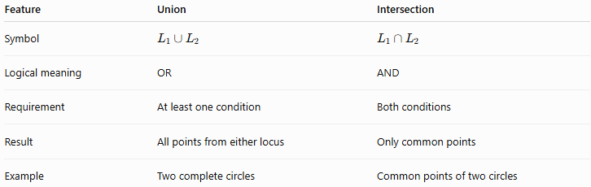
Feature | Union | Intersection
Symbol | $$L_{1}∪L_{2}$$ | $$L_{1}∩L_{2}$$
Logical meaning | OR | AND
Requirement | At least one condition | Both conditions
Result | All points from either locus | Only common points
Example | Two complete circles | Common points of two circles
Example
Suppose:
$$L_{1}=\left\{P:PA=5\right\}$$
and:
$$L_{2}=\left\{P:PB=3\right\}.$$
Union
$$\boxed{PA=5\text{ or }PB=3}$$
gives both circles.
Intersection
$$\boxed{PA=5\text{ and }PB=3}$$
gives only the common point(s) of the two circles.

Important Example: Two Circle Loci
# Source: AI Source: Provided by: [Data Path: Persons Table -> ID Column: 1, Name_En Column: Motasem Essam] -> From: [ChatGPT] on [7/25/2026]
Let:
$$A=\left(0 , 0\right)$$
and:
$$B=\left(6 , 0\right).$$
Suppose:
$$PA=5$$
or:
$$PB=5.$$
The first locus is:
$$x^{2}+y^{2}=25.$$
The second locus is:
$${\left(x-6\right)}^{2}+y^{2}=25.$$
Therefore the union is:
$$\boxed{\left\{\left(x , y\right):x^{2}+y^{2}=25\right\}∪\left\{\left(x , y\right):{\left(x-6\right)}^{2}+y^{2}=25\right\}}$$
It represents both complete circles.
Their intersection points are:
$$\boxed{\left(3 , 4\right),\left(3 , -4\right)}$$
but those points are simply shared by the two circles; the union contains the rest of both circles as well.

Union in Coordinate Geometry
# Source: AI Source: Provided by: [Data Path: Persons Table -> ID Column: 1, Name_En Column: Motasem Essam] -> From: [ChatGPT] on [7/25/2026]
If two loci are represented by equations or inequalities, their union represents points satisfying at least one condition.
For example:
$$L_{1}:x^{2}+y^{2}=9$$
and:
$$L_{2}:y=x.$$
Then:
$$\boxed{L=L_{1}∪L_{2}}$$
means:
$$\boxed{\left(x^{2}+y^{2}=9\right)\text{ or }\left(y=x\right)}$$
The result contains the entire circle and the entire line.

Union of Regions vs Union of Locus Boundaries
# Source: AI Source: Provided by: [Data Path: Persons Table -> ID Column: 1, Name_En Column: Motasem Essam] -> From: [ChatGPT] on [7/25/2026]
It is important to distinguish between a locus and a region.
For example:
$$x^{2}+y^{2}=25$$
represents the circle itself.
But:
$$x^{2}+y^{2}≤25$$
represents the closed disk.
Therefore:
$$\boxed{\left(x^{2}+y^{2}=25\right)∪\left(y=0\right)}$$
is a union of a circle and a line, while:
$$\boxed{\left(x^{2}+y^{2}≤25\right)∪\left(y=0\right)}$$
is a union of a disk and a line.
The mathematical operation is the same, but the sets being combined are different.

Union and Multiple Geometric Conditions
# Source: AI Source: Provided by: [Data Path: Persons Table -> ID Column: 1, Name_En Column: Motasem Essam] -> From: [ChatGPT] on [7/25/2026]
When a problem says:
Find the locus of $P$satisfying condition A or condition B.
use:
$$\boxed{\text{Condition A}→L_{1}} \\ \boxed{\text{Condition B}→L_{2}}$$
then:
$$\boxed{L=L_{1}∪L_{2}}.$$
When it says:
Find the locus satisfying condition A and condition B.
use:
$$\boxed{L=L_{1}∩L_{2}}.$$
This gives a useful rule:
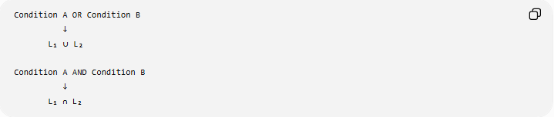
Condition A OR Condition B
↓
L₁ ∪ L₂

Condition A AND Condition B
↓
L₁ ∩ L₂

Set-Theoretic Properties
# Source: AI Source: Provided by: [Data Path: Persons Table -> ID Column: 1, Name_En Column: Motasem Essam] -> From: [ChatGPT] on [7/25/2026]
Union of loci follows the normal properties of set union.
Commutative
$$\boxed{L_{1}∪L_{2}=L_{2}∪L_{1}}$$
The order does not matter.
Associative
$$\boxed{\left(L_{1}∪L_{2}\right)∪L_{3}=L_{1}∪\left(L_{2}∪L_{3}\right)}$$
Idempotent
$$\boxed{L_{1}∪L_{1}=L_{1}}$$
Identity
If $∅$is the empty set:
$$\boxed{L_{1}∪∅=L_{1}}$$
Absorption with Intersection
$$\boxed{L_{1}∪\left(L_{1}∩L_{2}\right)=L_{1}}$$
These properties can be useful when simplifying complicated locus descriptions.

Union of Loci in Geometric Construction
# Source: AI Source: Provided by: [Data Path: Persons Table -> ID Column: 1, Name_En Column: Motasem Essam] -> From: [ChatGPT] on [7/25/2026]
Union is useful when a construction has multiple possible solutions.
Example: Fixed Distance from Either of Two Points
Suppose $P$must be:
- $4$cm from $A$, or
- $3$cm from $B$.
Construct:
- Circle centered at $A$, radius $4$.
- Circle centered at $B$, radius $3$.
- Take the union of the two circles.
Thus:
$$\boxed{L=C\left(A , 4\right)∪C\left(B , 3\right)}$$
Every point on either circle satisfies at least one condition.

Union of Two Angle-Bisector Loci
# Source: AI Source: Provided by: [Data Path: Persons Table -> ID Column: 1, Name_En Column: Motasem Essam] -> From: [ChatGPT] on [7/25/2026]
For two intersecting lines $l_{1}$and $l_{2}$, the complete locus:
$$d\left(P , l_{1}\right)=d\left(P , l_{2}\right)$$
consists of two perpendicular lines.
If:
$$L_{i}=\text{internal angle bisector}$$
and:
$$L_{e}=\text{external angle bisector},$$
then:
$$\boxed{L=L_{i}∪L_{e}}.$$
This is a particularly important geometric example of a locus naturally expressed as a union.

Union of Conic Loci
# Source: AI Source: Provided by: [Data Path: Persons Table -> ID Column: 1, Name_En Column: Motasem Essam] -> From: [ChatGPT] on [7/25/2026]
Different conic loci can also be combined.
For example:
$$L_{1}=\text{ellipse}$$
and:
$$L_{2}=\text{hyperbola}.$$
Then:
$$\boxed{L=L_{1}∪L_{2}}$$
contains all points on either conic.
The union itself generally is not a single conic.
This is important: combining two loci does not necessarily produce another locus belonging to the same geometric classification.

Union Does Not Mean "Connect Them"
# Source: AI Source: Provided by: [Data Path: Persons Table -> ID Column: 1, Name_En Column: Motasem Essam] -> From: [ChatGPT] on [7/25/2026]
A common misunderstanding is that taking the union means drawing a new curve connecting the two loci.
It does not.
The union simply contains every point belonging to either set.
For example:
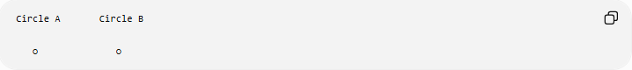
Circle A Circle B

○ ○
The union is:
○ ○
not a new curve connecting them.

Union vs Combined Locus
# Source: AI Source: Provided by: [Data Path: Persons Table -> ID Column: 1, Name_En Column: Motasem Essam] -> From: [ChatGPT] on [7/25/2026]
There is an important distinction:
Union
$$\boxed{L_{1}∪L_{2}}$$
means:
A point belongs to at least one of the loci.
Intersection
$$\boxed{L_{1}∩L_{2}}$$
means:
A point belongs to both loci simultaneously.
Combination of Conditions
A geometric problem may contain both:
$$\boxed{\left(L_{1}∪L_{2}\right)∩L_{3}}$$
This means:
The point belongs to $L_{3}$and belongs to at least one of $L_{1},L_{2}$.
So:
$$\boxed{\left(L_{1}∪L_{2}\right)∩L_{3}=\left(L_{1}∩L_{3}\right)∪\left(L_{2}∩L_{3}\right)}$$
by distributivity.

Classification Summary
# Source: AI Source: Provided by: [Data Path: Persons Table -> ID Column: 1, Name_En Column: Motasem Essam] -> From: [ChatGPT] on [7/25/2026]
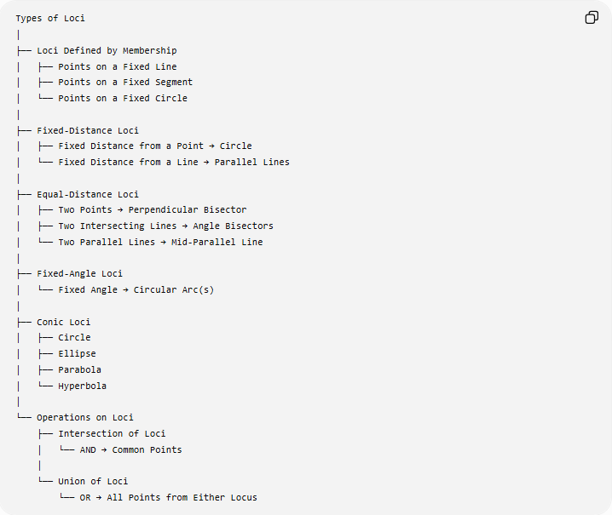
Types of Loci
│
├── Loci Defined by Membership
│ ├── Points on a Fixed Line
│ ├── Points on a Fixed Segment
│ └── Points on a Fixed Circle
│
├── Fixed-Distance Loci
│ ├── Fixed Distance from a Point → Circle
│ └── Fixed Distance from a Line → Parallel Lines
│
├── Equal-Distance Loci
│ ├── Two Points → Perpendicular Bisector
│ ├── Two Intersecting Lines → Angle Bisectors
│ └── Two Parallel Lines → Mid-Parallel Line
│
├── Fixed-Angle Loci
│ └── Fixed Angle → Circular Arc(s)
│
├── Conic Loci
│ ├── Circle
│ ├── Ellipse
│ ├── Parabola
│ └── Hyperbola
│
└── Operations on Loci
├── Intersection of Loci
│ └── AND → Common Points
│
└── Union of Loci
└── OR → All Points from Either Locus

Union of Loci vs Intersection of Loci
# Source: AI Source: Provided by: [Data Path: Persons Table -> ID Column: 1, Name_En Column: Motasem Essam] -> From: [ChatGPT] on [7/25/2026]
$$\boxed{\text{Union}→\text{OR}→\text{At Least One}} \\ \boxed{\text{Intersection}→\text{AND}→\text{All}}$$
For example:
$$\boxed{PA=5\text{ or }PB=5→\text{two circles}}$$
whereas:
$$\boxed{PA=5\text{ and }PB=5→\text{intersection of the two circles}}$$

Key Points
# Source: AI Source: Provided by: [Data Path: Persons Table -> ID Column: 1, Name_En Column: Motasem Essam] -> From: [ChatGPT] on [7/25/2026]
- Union of loci is written:
$$\boxed{L_{1}∪L_{2}}.$$
- It contains points belonging to at least one locus.
- Its logical meaning is:
$$\boxed{\text{OR}}.$$
- The loci may intersect, be disjoint, or coincide.
- A union can contain different geometric objects, such as:
$$\text{line}∪\text{circle}.$$
- Multiple loci can be united:
$$\boxed{L_{1}∪L_{2}∪⋯∪L_{n}}.$$
- Union is different from intersection:
$$\boxed{L_{1}∪L_{2}≠L_{1}∩L_{2}}$$
in general.
- Intersection means AND:
$$P∈L_{1}∩L_{2}.$$
- Union means OR:
$$P∈L_{1}∪L_{2}.$$
- The complete locus of points equidistant from two intersecting lines is a useful example of a union of two angle-bisector lines.

Core Principle
# Source: AI Source: Provided by: [Data Path: Persons Table -> ID Column: 1, Name_En Column: Motasem Essam] -> From: [ChatGPT] on [7/25/2026]
$$\boxed{P∈L_{1}∪L_{2} ⟺ P∈L_{1}\text{ or }P∈L_{2}}$$
Therefore:
$$\boxed{\text{Union of Loci}=\text{All points satisfying at least one locus condition}}$$

Conclusion
# Source: AI Source: Provided by: [Data Path: Persons Table -> ID Column: 1, Name_En Column: Motasem Essam] -> From: [ChatGPT] on [7/25/2026]
Union of Loci is an operation used to combine multiple possible locus sets into one complete set. Unlike the intersection of loci, which keeps only points satisfying all conditions simultaneously, the union keeps every point satisfying at least one condition. It is especially useful when a geometric problem has alternative possibilities, multiple branches, multiple angle bisectors, or several separate locus components.
$$\boxed{{\text{Locus}}_{1} OR {\text{Locus}}_{2} ⟹ L_{1}∪L_{2}}$$

